National Institute of Electronics and Information Technology, Ropar
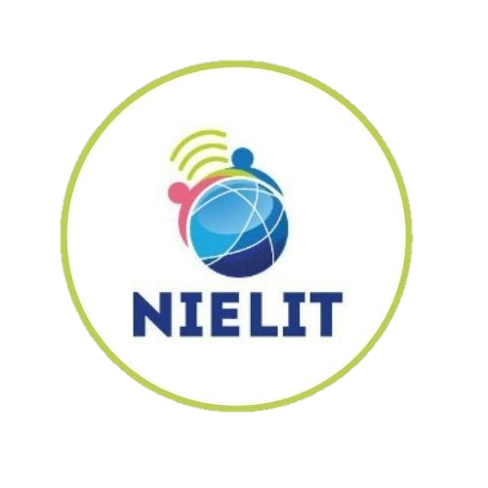
Submitted By:
Kamalpreet kaur
Submitted To:
Ms Ravneet kaur.

July2026

July2026
project report on
ai in eduction

Artificial Intelligence in Education:
Transforming the Future of Learning
A Comprehensive Research Report on Opportunities, Applications, and Challenges

1. Introduction to Artificial Intelligence
Artificial Intelligence (AI) represents one of the most transformative technological paradigm shifts of the 21st century. At its core, AI refers to the simulation of human intelligence processes by machines, particularly computer systems. These processes include learning (the acquisition of information and rules for using it), reasoning (using rules to reach approximate or definite conclusions), and self-correction. Over the past decade, advancements in computational power, algorithmic sophistication, and the exponential growth of data have propelled AI from a theoretical branch of computer science into a ubiquitous tool driving industry-wide evolution.
Modern AI systems utilize technologies such as Machine Learning (ML), Natural Language Processing (NLP), Computer Vision, and Neural Networks to analyze complex data patterns, make predictions, and automate decision-making processes. From autonomous vehicles and predictive healthcare to intelligent virtual assistants, AI is redefining how humans interact with technology and process information, paving the way for a major restructuring of societal and economic infrastructures.
2. Understanding AI in Education (AIEd)
In the educational sector, AI (frequently termed AIEd) refers to the integration of intelligent technologies into teaching environments, institutional workflows, and learning management systems. Rather than replacing human educators, AI in education acts as a cognitive amplifier and administrative facilitator. It transitions the traditional, rigid 'one-size-fits-all' pedagogical framework into a fluid, data-driven, and highly adaptive ecosystem.
AIEd encompasses software capable of assessing student knowledge levels in real-time, digital tools that assist educators with automatic grading, and predictive analytics that help institutions track student retention. By embedding intelligent software into curriculum delivery, education changes from a passive broadcast model to an interactive partnership between students, educators, and intelligent agents.
3. Key Benefits of AI in Education
- Hyper-Personalized Learning: AI systems can analyze an individual student’s performance, strengths, weaknesses, and learning pace. The technology automatically adapts the curriculum format, difficulty, and delivery speed to match the learner's precise cognitive needs.
- 24/7 Academic Support: AI-powered tutoring systems and chatbots offer students immediate feedback and guidance outside classroom hours, removing geographical and time barriers to academic support.
- Reduction of Administrative Burden: By automating routine administrative tasks such as grading multiple-choice assessments, tracking attendance, and processing enrollments, AI frees up educators to focus on mentorship and deep pedagogical engagement.
- Informed, Data-Driven Insights: AI dashboards provide educators with predictive diagnostics, highlighting exactly which concepts a student is struggling with or identifying individuals at risk of academic failure long before traditional exams would reveal it.
- Enhanced Accessibility: AI tools like automated closed-captioning, text-to-speech conversion, and real-time language translation break down barriers for students with learning disabilities, visual or hearing impairments, or non-native language backgrounds.
4. Practical Uses and Applications of AI in Education
- Intelligent Tutoring Systems (ITS): Platforms like Carnegie Learning or Century utilize advanced cognitive modeling to act as private digital tutors, guiding students step-by-step through mathematical and scientific problems, intervening with precise hints when errors occur.
- Automated Grading and Assessment: AI tools grade essays, short answers, and coding submissions using advanced natural language processing. Systems provide immediate, structured qualitative feedback to students, significantly shortening the grading lifecycle.
- Generative AI for Lesson Planning: Educators leverage large language models (LLMs) to design customizable lesson plans, formulate exam questions, generate creative prompts, and create diverse reading materials personalized for varying comprehension tiers.
- Smart Content Creation: AI tools convert traditional static textbooks into dynamic interactive learning modules. They can automatically extract key concepts, create interactive flashcards, summarize dense chapters, and embed self-assessment quizzes.
- Institutional Operations and Enrollment: Universities utilize predictive AI modeling to optimize enrollment management, project retention rates, allocate financial aid strategically, and handle student inquiries efficiently via automated admissions chatbots.
5. Challenges and Ethical Considerations
- Data Privacy and Security: AI engines rely on massive sets of sensitive student data, including performance metrics, behavior tracking, and demographic details. Ensuring strict adherence to data privacy regulations (such as FERPA and GDPR) is an ongoing, critical concern.
- Algorithmic Bias and Discrimination: If the historical data used to train AI models contains systemic biases, the software can replicate and amplify these disparities. This could lead to unfair student evaluations, biased institutional grading, or skewed tracking algorithms.
- Academic Integrity and Misuse: The widespread accessibility of generative AI systems makes it difficult to verify student authorship. Plagiarism detection software struggles to keep pace with sophisticated LLMs, creating a need for new frameworks of authentic assessment.
- The Digital Divide: Deploying modern AI educational tools requires robust digital infrastructure, high-speed internet, and updated hardware. Lower-income schools and developing regions risk being left further behind, widening the global educational equity gap.
- Diminished Human-to-Human Interaction: Over-reliance on automated tutoring software risks reducing social-emotional development. Crucial soft skills like collaboration, empathy, and interpersonal communication are uniquely nurtured through human-led mentorship and peer interaction.
6. Conclusion
Artificial Intelligence holds immense promise for the evolution of modern education. By automating routine workflows, customizing pedagogical pathways to fit individual learner dynamics, and delivering scalable tools for equity and accessibility, AI behaves as a foundational catalyst for positive academic change. However, maximizing its potential requires addressing critical challenges like algorithmic bias, data vulnerabilities, and the preservation of human-centric teaching.
Moving forward, the primary goal should not be the total automation of education, but rather a deliberate strategy of human-AI collaboration. When deployed ethically, safely, and equitably, artificial intelligence will empower educators and unlock new capabilities for learners worldwide.

